1. 
2. Before dirty our hands, let’s take a look at this from 10,000feet.
3. Elastic Beanstalk is used to deploy an app on AWS which is part of Cloud.
4. Why do we need cloud? What is Cloud.
   1. The most important feature of cloud is “On Demand Resource Provisioning”.
   2. Old days are gone, where we have to plan 30days ahead about the resources.  
      In cloud environment, we can get resource on-demand in instantly.
   3. Use Cases:  
      
      1. Online shopping app has varying loads throughout the year.
      2. On Thanksgiving Day, it has very high loads but other days not that much load.
      3. If you have Data Center with you (means you have your own resources), they will be sitting ideal for those days when these resources are not utilized.  
         But if you go for AWS Cloud, you can scale up or down anytime you want.
5. 
6. 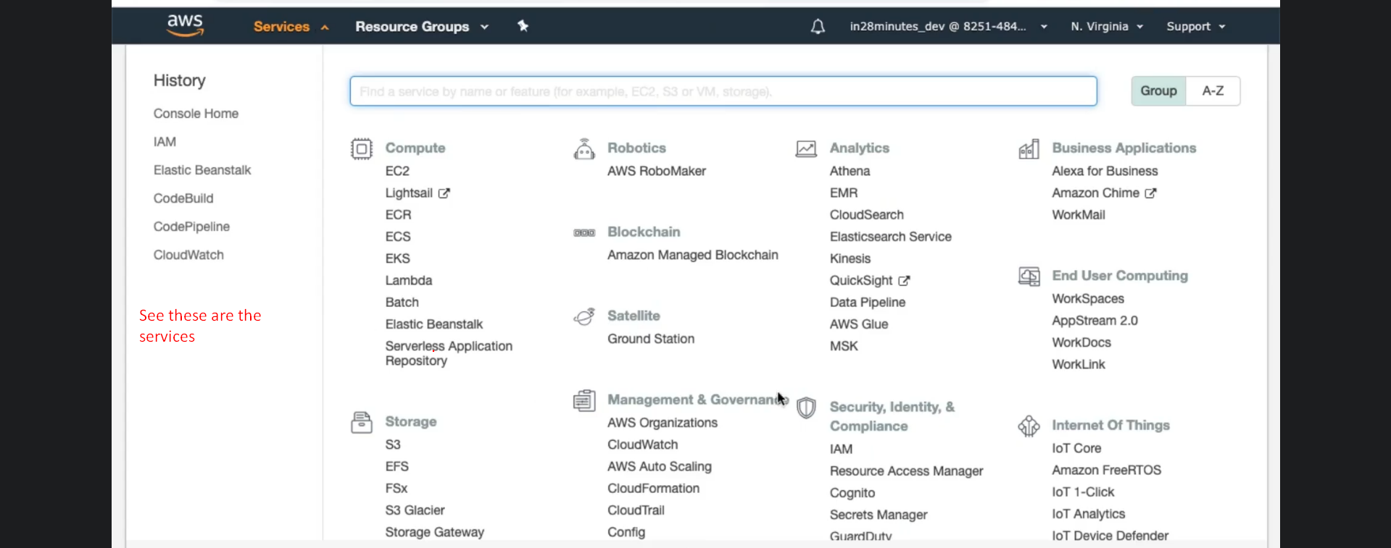
7. 
   1. So many services. Making a choice is very difficult specially when you’re getting started with AWS.
   2. That is where Elastic Beanstalk aims to make it easy.
   3. It helps you get started with cloud.
   4. It helps you deploy your app with a very simple interface.
   5. It helps to deploy a variety of apps on a variety of platforms.
      1. You can deploy app on tomcat.
      2. You can run Java, Python, NodeJS app etc.
   6. In the subsequent steps, we will deploy REST API Web App, Full Stack App, Container, Multi-Container Apps using Elastic BeanStalk.